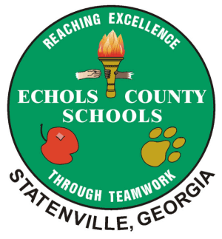
Echols County Schools
Wellness Assessment Tool 2019-2020
Goal | Measure | Outcome
Echols County Schools will establish a wellness committee that:  - meets 4 times yearly  - reviews/updates the wellness policy annually | List of wellness committee members and sign in sheet for 4 meetings and agenda for meeting that involved review and update of policy.
Echols County Schools will strive to have at least 60% of staff members involved in one or more wellness activity throughout the year. | Data collected from participation through Microsoft Forms
Echols County Schools will increase physical activity within the classrooms daily to include an additional 30 minutes outside of physical education classes. (At least 12 classrooms participate every month.) | Data collected from participation through Microsoft Forms on a monthly basis.
Echols County Schools will have a wellness policy that mirrors the model wellness policy from the state. | Compare/Contrast our model to the state model using a checklist.
Echols County Schools will be in compliance in with the wellness policy in all areas. A score of 3 or better in all areas will indicate compliance. | Rubric to rate compliance in the areas of: School Wellness Committee, Wellness Implementation, Nutrition, and Physical Activity. The rubric will rate each area from 1-4. (1 being not in compliance and 4 being above standard compliance)

Wellness Policy Compliance Rubric for Echols County Schools

Area | Score 1  (no evidence of compliance) | Score 2  (Little evidence of compliance) | Score 3  (Substantial evidence of compliance) | Score 4  (Evidence of going beyond compliance)
School Wellness Committee
Wellness Implementation
Nutrition

Physical Activity

Strengths:

Areas to Improve:

